Dear Practitioner/Practice manager name ,
We would like to introduce you to our organisation and our respected member, member name member name .
The Pilates Alliance of Australasia (PAA) is Australia’s leading industry body for Pilates and has set standards and criteria for Pilates Education Bodies.
To become a PAA member, instructors must hold a government accredited Certiﬁcate IV, Diploma or Advanced Diploma in the Pilates Method, from a recognised PAA Education Body. These accredited courses consist of over 500 hours of theoretical and practical education, including programming for health conditions, musculoskeletal dysfunctions and injuries. For further information please visit our website at www.pilates.org.au.
PAA members are required to maintain a high level of competency through ongoing professional development. All major health insurers recognise PAA member services.
Member name member name would be happy to make an appointment to discuss their services further and to explain how your patients can be screened and supported to commence a Pilates exercise or rehabilitation program under their supervision. Member name member name contact details are provided below.

Sincerely,
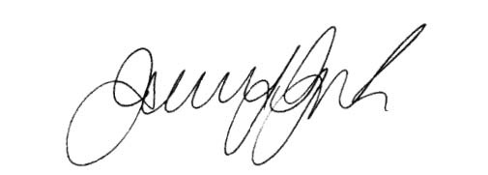
CONTACT NAME: Member Name Member Name
STUDIO NAME: Studio Name
ADDRESS: Studio Address
TELEPHONE: Telephone
EMAIL: Email
WEB: Website
OPENING HOURS: Opening Hours
Jenni Guest
President
Pilates Alliance of Australasia

